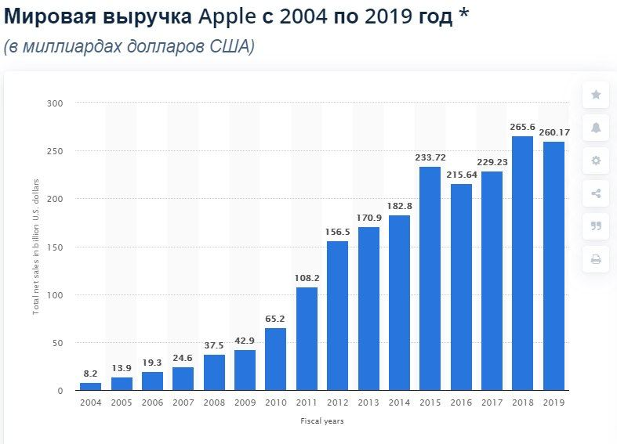
The Apple company began to produce their first products in 2004. Well, as we can see on the graph, the equipment of this company started selling not very well, but there were still people who bought it. This may be due to the high price of the product. And during 5 years, from 2005 to 2009, the company began to quietly raise its revenue and improve the quality of products, but with this increased prices for this quality. In the period from 2010 to 2011, we can see that the Apple company has become rapidly and confidently getting good earnings. This company has already become more of a brand, and everyone would like to have the products of this company. And in 2012, the revenue was more than 150 billion dollars. But that's not all, from 2013 to 2014, the revenue grew more and more. And already in 2015, they reached the mark of 233 billion dollars. Just think, in 2 years, the company's revenue grew by 1.5 times, this is incredible Throughout 2016 to 2017, the Apple company had a slight decline, but as they say, there is a lull only before the storm, and as a result, in 2018 the company reached the Maximum Result, the shot was just perfect. The company has become at the forefront of the sale of technology and began to produce new types of products. And in 2019, the company also did well and the profit was very high.

